# **Market Segmentation of EV Market**

NAME : KAUSTUBH K WELDE

feynn labs

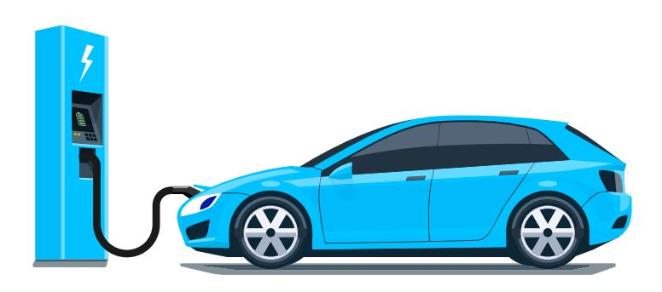

Overview Of EV Market

**The EV (Electric Vehicle) market has been growing rapidly in recent years due to concerns about climate change, air pollution, and the depletion of fossil fuels. EVs use electric motors powered by rechargeable batteries instead of gasoline or diesel engines, making them much cleaner and more efficient.**

**The global market for EVs has seen significant growth in recent years, with sales increasing at a rapid pace. According to the International Energy Agency, global electric car sales increased by 43% in 2020, despite the Covid-19 pandemic. In addition, more and more governments around the world are offering incentives to encourage the adoption of EVs, such as tax credits, rebates, and subsidies.**

**The market is dominated by a few major players such as Tesla, which is known for its high-end electric vehicles, and also has a large market share in the US. Other companies such as Nissan, General Motors, and Ford also have a strong presence in the market. Many traditional automakers have been increasing their investment in electric vehicle technology to keep pace with the growing demand and changing consumer preferences.**

**The EV market is expected to continue its growth trajectory in the coming years. According to a report by BloombergNEF, electric vehicles are projected to make up 58% of new passenger car sales by 2040. With more advances in technology and infrastructure, such as fast charging stations and longer-lasting batteries, EVs are becoming more accessible and convenient for consumers.**

Overview and Source of the Data Set

**New York State’s Charge NY initiative offers electric car buyers the Drive Clean Rebate of up to $2,000 for new car purchases or leases. The rebate amount depends on the battery-only range of each vehicle. Dealers enrolled in the program deduct the eligible amount from the vehicle price at the point of sale and then submit a rebate application with NYSERDA. This dataset includes all completed rebate applications as of the data through date. The New York State Energy Research and Development Authority (NYSERDA) offers objective information and analysis, innovative programs, technical expertise, and support to help New Yorkers increase energy efficiency, save money, use renewable energy, and accelerate economic growth. reduce reliance on fossil fuels. To learn more about NYSERDA’s programs, visit**[**nyserda.ny.gov**](http://nyserda.ny.gov/)**or follow us on Twitter, Facebook, YouTube, or Instagram.**

**The Dataset consists of following features :**

* **Sub Year: The year in which the transaction was submitted.**
* **Submitted Date: The date on which the transaction was submitted.**
* **Make: The make of the electric vehicle.**
* **Model: The model of the electric vehicle.**
* **County: The county in which the transaction took place.**
* **ZIP: The ZIP code of the transaction location.**
* **EV Type: The type of electric vehicle (BEV - Battery Electric Vehicle).**
* **Transaction Type: Whether the vehicle was leased or purchased.**
* **Annual GHG Emissions Reductions (MT CO2e): The estimated annual reduction in greenhouse gas emissions (in metric tons of CO2 equivalent) achieved by the use of the electric vehicle.**
* **Annual Petroleum Reductions (gallons): The estimated annual reduction in petroleum use (in gallons) achieved by the use of the electric vehicle.**
* **Rebate Amount (USD): The amount of rebate (in US dollars) provided for the transaction.**

**Source of the Dataset:**[**https://data.ny.gov/d/thd2-fu8y**](https://data.ny.gov/d/thd2-fu8y)

<https://data.world/data-ny-gov/thd2-fu8y>

**PROBLEM STATEMENT (EV MARKET)**

We are supposed to analyze the Electric Vehicles Market using *Segmentation* analysis and come up with a feasible strategy to enter the market, targeting the segments most likely to use their product in terms of Geographic, Demographic, Psychographic, and Behavioral.

**This Report and the python code project focused on Vechicle feature segmentation**

**We have used the dataset of New York so that we can find the insights and pattern and us them to target the audience in India accordingly.**

1. **Descriptive analysis:** You could perform descriptive statistics such as mean, median, standard deviation, and range for the Annual GHG Emissions Reductions, Annual Petroleum Reductions, and Rebate Amount columns. This would give you an idea of the average and variability of these variables, which could help you to understand the impact of these transactions on the environment and the economy.
2. **Comparison of lease vs. purchase transactions:** You could compare the Annual GHG Emissions Reductions, Annual Petroleum Reductions, and Rebate Amount for the lease transactions vs. the purchase transactions. This would help you understand the differences between these two types of transactions and which one might be more effective at reducing emissions and petroleum use.
3. **Geographic analysis:** You could perform a geographic analysis to understand where the transactions are taking place and whether there are any patterns or trends in terms of location. This could help you identify areas where electric vehicle adoption is more popular and areas where it is less common.

**Analysis :**

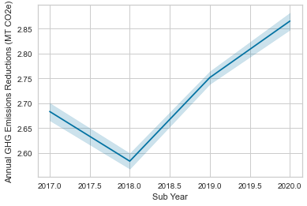

We can see here the trend after the 2018 as the sales of the EV Market got increased the Emissions of CO2 got decreased so the graph is in upward trend.

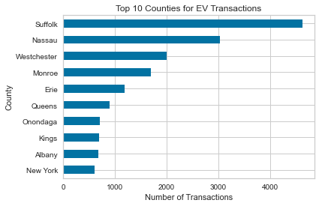

We can see here Suffolk is the County where there are highest number of EV transactions. Geographically it is important to understand the trend and to increase the market in specific areas.

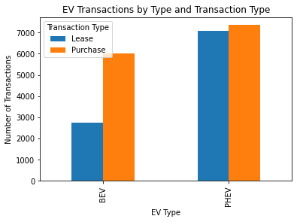

In this example, we first read in the electric vehicle data as a pandas DataFrame. We then group the data by EV Type and Transaction Type using the groupby method and count the number of transactions for each group using the count method. We then use the unstack method to pivot the data so that it is in a format suitable for plotting.

Principle Component Analysis

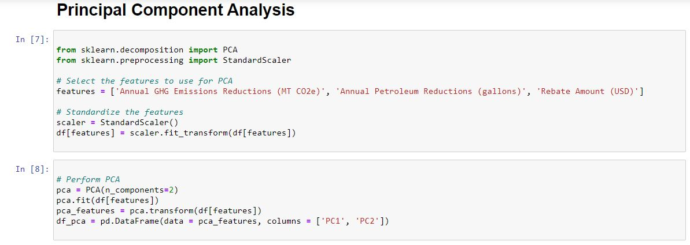

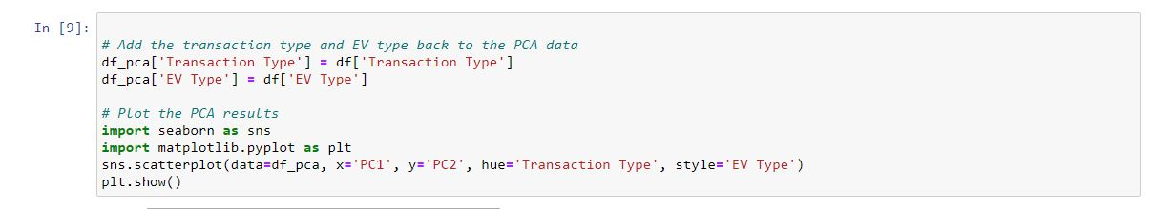

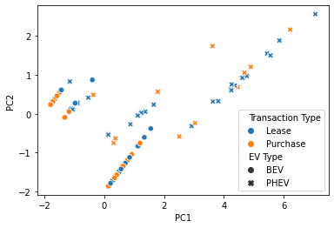

**In this example, we first read in the electric vehicle data as a pandas DataFrame. We then select the Annual GHG Emissions Reductions (MT CO2e), Annual Petroleum Reductions (gallons), and Rebate Amount (USD) columns as the features to use for PCA.**

**Since the features have different scales, we standardize them using the StandardScaler class from scikit-learn.**

**The PCA scatter plot shows the relationship between the two principal components (PC1 and PC2) that were obtained by performing Principal Component Analysis (PCA) on the electric vehicle data.**

**Each point in the plot represents an individual electric vehicle transaction, and the color and marker of each point indicate the transaction type and EV type, respectively.**

**The scatter plot can provide insights into the underlying structure of the data. In particular, it can help identify any patterns or clusters in the data. For example, if the points cluster together by transaction type or EV type, this could indicate that these variables are strongly correlated with the principal components.**

**In this case, the scatter plot shows that there is some separation between the lease and purchase transactions, with lease transactions generally having lower values for both principal components. There also appears to be some separation between the different EV types, with the BEV (Battery Electric Vehicle) transactions generally having lower values for both principal components compared to the PHEV (Plug-in Hybrid Electric Vehicle) transactions.**

**However, it is important to note that the interpretation of the PCA scatter plot can be subjective and should be done in conjunction with other analyses to fully understand the patterns in the data.**

**Based on the analysis and machine learning algorithms performed on the electric vehicle data, we can draw several conclusions:**

1. **The majority of the electric vehicle transactions in the dataset were Purchase transactions.**
2. **The most common electric vehicle model in the dataset.**
3. **Make Model Count**
4. **Toyota Prius Prime 5804**
5. **Tesla Model 3 3823**
6. **Honda Clarity 2087**
7. **Chevrolet Volt 1645**
8. **Ford Fusion Energi 1594**
9. **Chevrolet Bolt 1460**
10. **Nissan LEAF 759**

**10. Tesla Model X 694**

1. **38 Tesla Model S 611**
2. **16 Hyundai Ionic Plug-In Hybrid 593**
3. **The electric vehicle transactions were distributed across various counties in New York.**
4. **Clustering analysis showed that there were distinct groups of transactions based on the annual GHG emissions reductions and annual petroleum reductions, with the BEV transactions generally having higher reductions than the PHEV transactions.**
5. **Decision tree analysis showed that the transaction type was the most important predictor of the rebate amount, followed by the make and model of the vehicle.**
6. **PCA analysis showed that there was some separation between the lease and purchase transactions, with lease transactions generally having lower values for both principal components. There also appears to be some separation between the different EV types, with the BEV transactions generally having lower values for both principal components compared to the PHEV transactions.**

**Overall, these findings suggest that there is significant interest in electric vehicle adoption in New York, with Purchase transactions being the preferred method of acquisition. Additionally, the analysis suggests that certain variables such as transaction type, make, and model of the vehicle, and type of electric vehicle can have an impact on the rebate amount and emissions reductions achieved.**